Deploy Backend application with Nginx on CentOS

Step 1: - Clone the code inside your local.
- git clone https://softobiztechnologies.visualstudio.com/GIS%20Intertown/_git/GIS_Intertown_Configuration_Backend

Step 2: - Install the NVM, Node and Yarn. (https://tecadmin.net/how-to-install-nvm-on-centos-7/ )
- NVM install command
- sudo yum install curl -y
- sudo curl https://raw.githubusercontent.com/creationix/nvm/master/install.sh | bash
- source ~/.bashrc
- nvm ls-remote
- Node install command
- nvm install node
- nvm install 18.15.0
- nvm use 18.15.0
- Yarn installs command
- npm install --global yarn
- npm install -g npm@9.8.1
- yarn –version

Step 3: - Go to the root of the application. Now run the application for testing purpose. Run these commands inside over terminal
- yarn
Now install pm2 package
- npm install -g pm2
- pm2 start index.js
Now our application running inside over local. This time application running localhost:8080 so now we redirect this application over domain name with using Nginx server.

Step 4: - Install nginx inside your local (Centos).
- $ sudo yum update
- $ sudo yum install nginx
- $ systemctl start nginx
- $ systemctl enable nginx

Step 5: - Go inside this file “vim /etc/hosts/” and paste here domain name those name you give in nginx conf file like this.
- 127.0.0.1 Domain_Name(e.g., nodeapplication.info);

Step 6: - Go inside the default file and change this configuration file.
- cd /etc/nginx/conf.d (go to this location) ￼
- Vim my_proxy.conf (open this file and change here configuration)

After open my_proxy.conf file paste all lines inside that.
server {
listen 80;
server_name Domain_Name(e.g., nodeapplication.info);
location / {
proxy_pass http://localhost:8080; # Replace with your backend server's address
proxy_set_header Host $host;
proxy_set_header X-Real-IP $remote_addr;
proxy_set_header X-Forwarded-For $proxy_add_x_forwarded_for;
proxy_set_header X-Forwarded-Proto $scheme;
}
}
Now Run this command

- $ sudo nginx -t
- $ sudo systemctl reload nginx
- $ sudo firewall-cmd --permanent --add-service=http
- $ sudo firewall-cmd --reload
Now your search your domain inside the browser Domain_Name(e.g., nodeapplication.info/test);

Deploy Frontend application with Nginx on CentOS

Step 1: - Clone the code inside your local.
- git clone https://softobiztechnologies.visualstudio.com/GIS%20Intertown/_git/GIS%20Intertown

Step 2: - Install the NVM, Node and Yarn. (If you install nvm,node and yarn in upper step then you can install only node 13.7.0 version)
- NVM install command
- sudo apt install curl
- sudo curl https://raw.githubusercontent.com/creationix/nvm/master/install.sh | bash
- sudo source ~/.bashrc
- Node install command
- sudo nvm install node
- sudo nvm install 13.7.0
- sudo nvm use 13.7.0
- Yarn installs command
- sudo npm install --global yarn
- sudo yarn –version

Step 3: - Doing some changes inside this code
- Go to root directory of the application. Inside this open “package.json” file and change here domain name that domain name you access your frontend before creating the build.
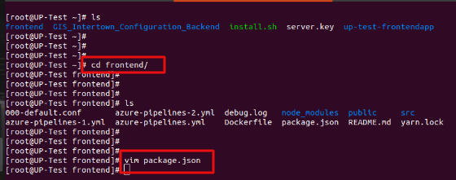
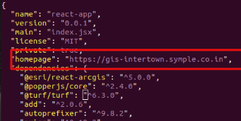
- Go to the root directory of the application. Inside this go “src” directory and inside src directory open “clientConfig.js”. Type here your backend Ip address or domain name before creating the build.
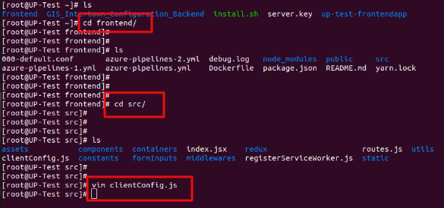
Inside the export default put production.
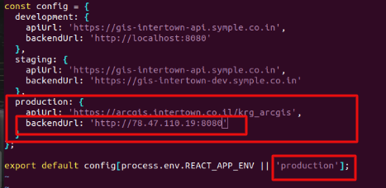
- Go to the backend root directory and inside that select vim index.js
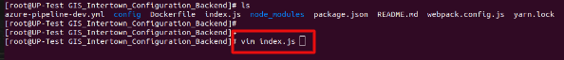
Paste here frontend URL.
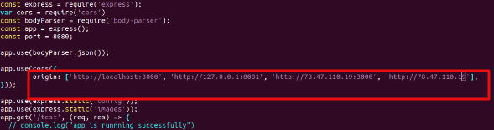
Step 4: - Now create build and for that run these command from root directory of the application
- yarn
- yarn build
Step 5: - Put the Build directory all data inside nginx default page path ( /usr/share/nginx/html/ ) and run this command from build directory.
- Cp -r * /usr/share/nginx/html/
And restart the nginx server
- systemctl restart nginx
Step 6: - If you define domain name inside the nginx.conf file then access domain name otherwise access application with Ip address.

